Vertical Guidance
The vertical guidance option selected in the Attachment Manager screen changes how the system looks at and extends the design surface beneath the blade to calculate the cut / fill values.
1. To select an option for Vertical Guidance access the Attachment Manager screen by going to the Machine Setup tile and selecting the menu button:
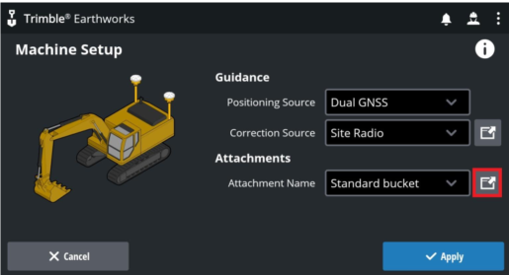
2. Select a focus, or side of the bucket or blade to guide to:
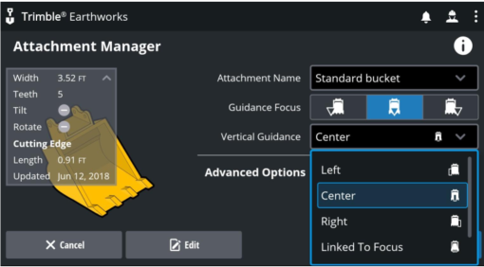
3. Select each of the guidance options available under Advanced Options below to test:
Note: some of these may be specific to certain machines and may not be available with your setup
- Right
- Center
- Left
- Linked to focus
- 2 points
4. Tap Apply
Apply a Custom Inset
The Attachment Manager screen can be accessed with 2 different methods. Choose one method from below to configure a Custom Inset:
Note- For 2 point guidance there is no custom inset option for a bucket.
Method 1
Press and hold the Blade Focus shortcut button until the Attachment Manager screen appears:
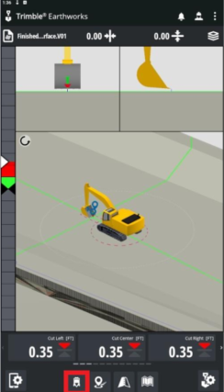
Method 2
Access Blade Manager screen via the Machine Settings menu.
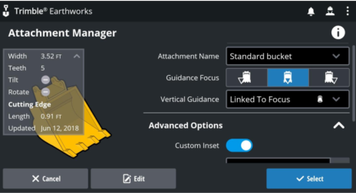
1. Select either Linked to Focus from the vertical guidance menu. Open Advanced Options and toggle on Custom Inset.
2. Enter the custom Inset value desired.
3. Tap apply.
Overcut Protection
1. Access the Attachment or Blade Manager Screen.Open Advanced Options and toggle Overcut protection on,.
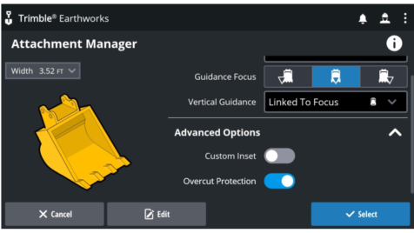
2. Tap Apply
Note- Overcut Protection is useful when moving material across the toe of a slope, for example moving excess material down from the batter to the floor of the excavation.
Toggle Overcut Protection off when the task is done to receive accurate guidance on the rest of the job. When Overcut Protection is enabled the surface adjusts to protect the toe of the slope

